Business:

Operating Instructions
in accordance with GefStoffV and VSG 4.5

…
These SAMPLE operating instructions have to be adapted to the operating conditions!

Workplace/field of work: Cleaning of the milking system
 | Hazardous substance designation
 | Sodium hydroxide, sodium hypochlorite
 | Dangers to Humans and the Environment
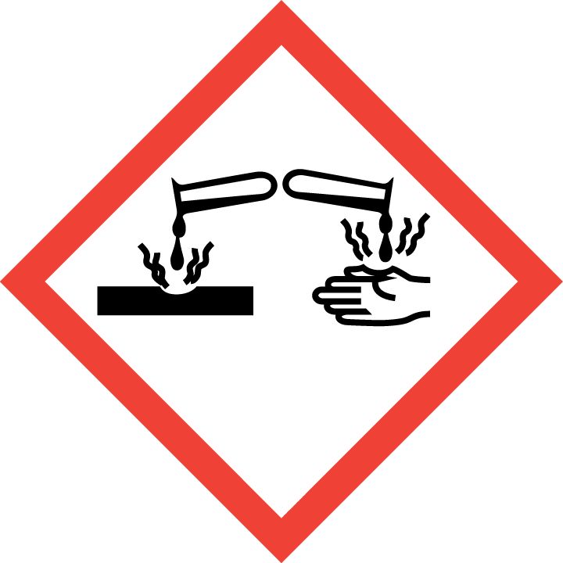  Social Insurance for Agriculture, Forestry and Horticulture | - Causes severe burns to the eyes, skin and mucous membranes.  - Swallowing causes burns to the stomach and intestines.  - Contact with acid releases toxic gases.  - Very toxic to water organisms. |  | 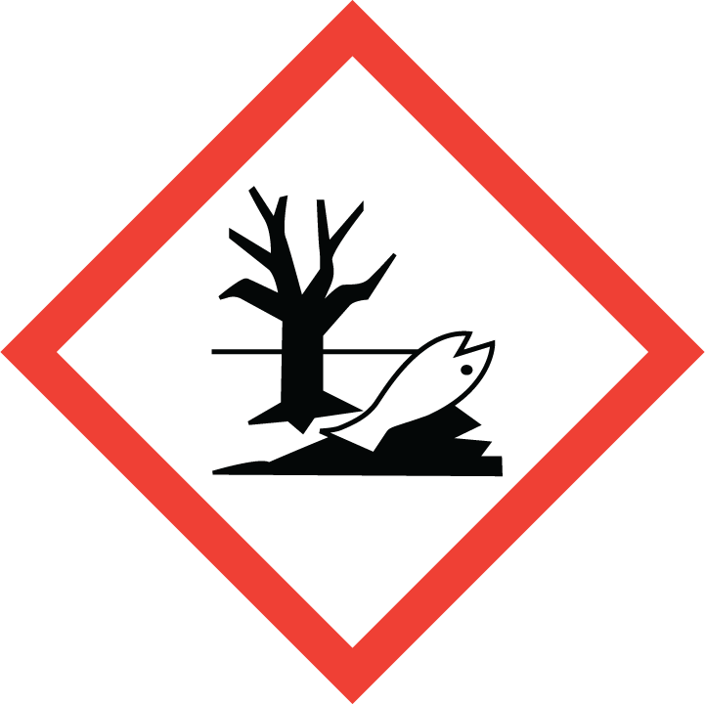  Keep operating instructions w i t h i n e a s y r e a c h!

Protective measures and rules of behaviour

     | Further details of the supplier providing the safety data sheet.  - Eye protection: Wear tightly fitting safety goggles.  - Hand protection: Wear chemical-resistant protective gloves.  - Body protection: Wear long-sleeved work clothes, a rubber apron and rubber boots. Avoid contact with the eyes, skin and clothing  - Wash your hands immediately after handling the product.  - Ensure adequate ventilation, especially in closed rooms. Keep containers tightly closed. Keep away from food, drinks and animal feed.  Do not eat, drink or smoke while using.  Children must not be allowed access to the product. |  |   

What to do in the case of Accidents

 | - Implement the alarm, escape and rescue plans.  - Ensure adequate ventilation. Do not inhale the gases.  - Change and wash contaminated clothing immediately.  - Precipitate gases, vapours and mists with a water spray jet. |  | 

First Aid

 | - Always ensure self-protection when applying first aid measures.  - After contact with the eyes: Rinse for 10 minutes under running water with the eyelids open wide or use an eye rinsing solution. Always consult an ophthalmologist!  - After contact with the skin: Remove contaminated clothing immediately and clean the skin.  - After inhaling: Fresh air! If unconscious, keep the airways clear.  - After swallowing: Do not induce vomiting.  - First aider: …………….………………… Doctor:………………………………………………  Poison Information Centre: 0228/ 1924 Emergency telephone number: 112 | 

Proper disposal

Do not allow the product to drain into surface waters or the sewage system. Take up with liquid-binding material (e.g. diatomaceous earth). Arrange for disposal in accordance with the manufacturer's instructions in the safety data sheet (section 13).
Date: ………………201…. Contractor’s signature: ………………………………………………..

Date: April 2015

