Business:

Operating Instructions
in accordance with GefStoffV and VSG 4.5

…
These SAMPLE operating instructions have to be adapted to the operating conditions!

Workplace/field of work: Cleaning of the milking system
 | Hazardous substance designation
 | Nitric acid, phosphoric acid
 | Dangers to Humans and the Environment
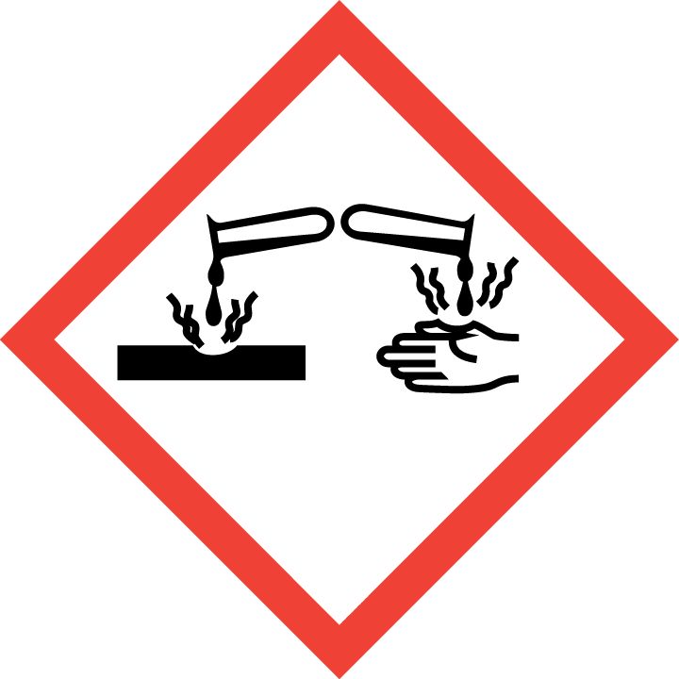  Danger  Social Insurance for Agriculture, Forestry and Horticulture | - Causes burns to the eyes, skin and mucous membranes.  - Swallowing causes burns to the stomach and intestines.  - The product is slightly hazardous to water. |  | 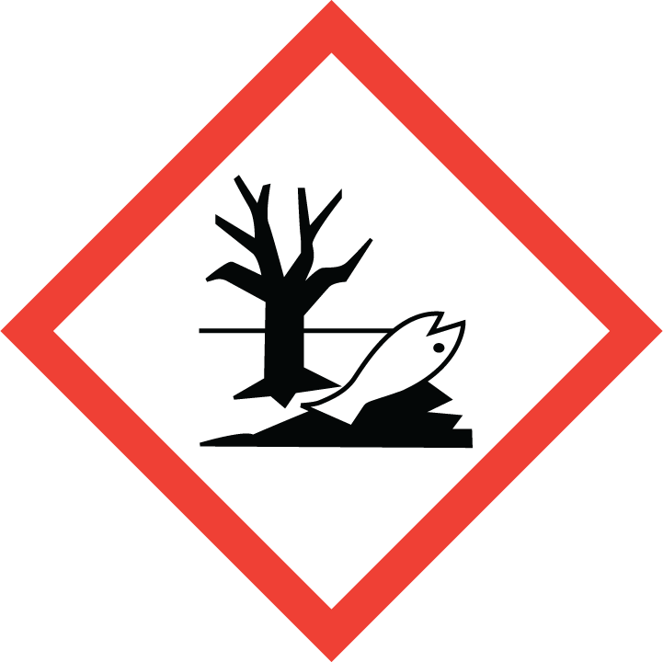

Protective measures and rules of behaviour
Keep operating instructions w i t h i n e a s y r e a c h!

   | Further details of the supplier providing the safety data sheet.  - Eye protection: Wear tightly fitting safety goggles.  - Hand protection: Wear chemical-resistant protective gloves.  - Body protection: Wear acid-resistant protective clothing (rubber boots, rubber apron).  - Keep containers tightly closed. Ensure good ventilation.  - Keep away from food, drinks and animal feed.  - Must not enter drains, water bodies.  - Never add water.  - Never mix with alkaline substances. |  | 

What to do in the case of accidents

 | - Implement the alarm, escape and rescue plans.  - Ensure adequate ventilation.  - Avoid contact with the eyes, skin and clothing.  - Precipitate gases, vapours and mists with a water spray jet. |  | 

First Aid

 | - Always ensure self-protection when applying first aid measures.  - After contact with the eyes: Rinse for 10 minutes under running water with the eyelids open wide or use an eye rinsing solution. Always consult an ophthalmologist!  - After contact with the skin: Remove contaminated clothing immediately and clean the skin.  - After inhaling: Ensure the supply of fresh air. If unconscious, keep the airways clear.  - After swallowing: Do not induce vomiting.  - If you feel unwell, seek medical advice immediately.  - First aider: …………….………………… Doctor: …………………………………………….  Poison Information Centre: 0228/ 19240  Emergency telephone number: 112 | 

Proper disposal

Do not empty into drains or surface waters. In the case of accidental release, absorb with liquid-binding material (e.g. diatomaceous earth, vermiculite or sand). Arrange for disposal in accordance with the details in the safety data sheet (section 13).
Date: ………………201…. Contractor’s signature: ………………………………………………..

Date: April 2015

