Operating Instructions
acc. to the German Ordinance on Hazardous Substances and VSG 4.5

These EXAMPLE operating instructions must be adapted to the operating conditions.

Business:

Work area:
Type of work: Anaesthesia with isoflurane during piglet castration
Social security Agriculture Forestry and horticulture
 | hazard designation
 | Isoflurane
 | Risks for people and the environment
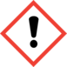  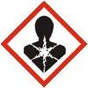 | - The main intake route is through the respiratory tract. Inhalation may cause damage to health.  - May irritate the respiratory tract. Causes mucous membrane irritation.  - May damage the cardiovascular and central nervous systems when inhaled.  - The inhalation of high vapour concentrations may cause drowsiness, dizziness or unconsciousness.  - Slightly volatile.  - Slightly hazardous to water, as heavier than water and hardly miscible with water.  - Not flammable. |  | Keep operating instructions in a safe place!

Protective measures and rules of conduct

 | - Provide good ventilation of the working area (3 to 5 air changes per hour).  - May only be stored and transported by trained personnel (expert knowledge) in compliance with the safety regulations.  - Wear protective gloves for hygienic reasons.  - Do not smoke, eat or drink.  - Avoid the inhalation of vapours and skin contact.  - Store containers in a well-ventilated location. Do not store together with food or animal feed. Store away from gases (e.g. oxygen).  - Comply with employment restrictions for expectant and breastfeeding mothers. |  | 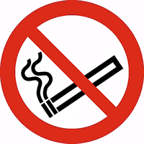  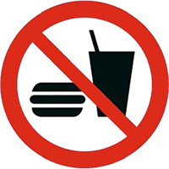

Behaviour in the event of accidents

   | - If there is a risk of isoflurane being released, leave the danger area.  - To re-enter the scene of the accident, wear a full-face mask with an AX filter, as well as eye, hand and body protection.  - Remove wet clothing.  - A fire may cause the release of carbon monoxide, carbon dioxide, hydrogen fluoride and hydrogen chloride. Wear self-contained breathing apparatus and a chemical protective suit. |  | 

First aid

 | - Always ensure self-protection during any first aid measures.  - In the case of eye contact, rinse for at least 10 minutes; seek medical attention.  - In the case of skin contact, clean the skin with soap under running water.  - If swallowed, rinse the mouth and seek medical attention.  - After inhalation, remove injured persons from the danger area and ensure the supply of fresh air.  - Consult a doctor in the event of symptoms.  - Immediate life-saving measures must be taken, depending on the situation.  - First responder: ……………...………………… Doctor…………………………………….  Poison Information Centre: 0228/ 19240 Emergency: 112

Proper disposal

Not hazardous waste according to the Waste Catalogue Ordinance (AVV). If recovery is not possible, wastes must be disposed of in accordance with local regulations.
Date: ……………… 20…. Signature of the entrepreneur………………………………………………: ……
(February 2019)

